**OPERATING SYSTEM - CS23431**

**EXP 1 ROLL NO: 230701047**

**AIM:**

To install and configure Linux operating system in a Virtual Machine.

**Installation/Configuration Steps:**

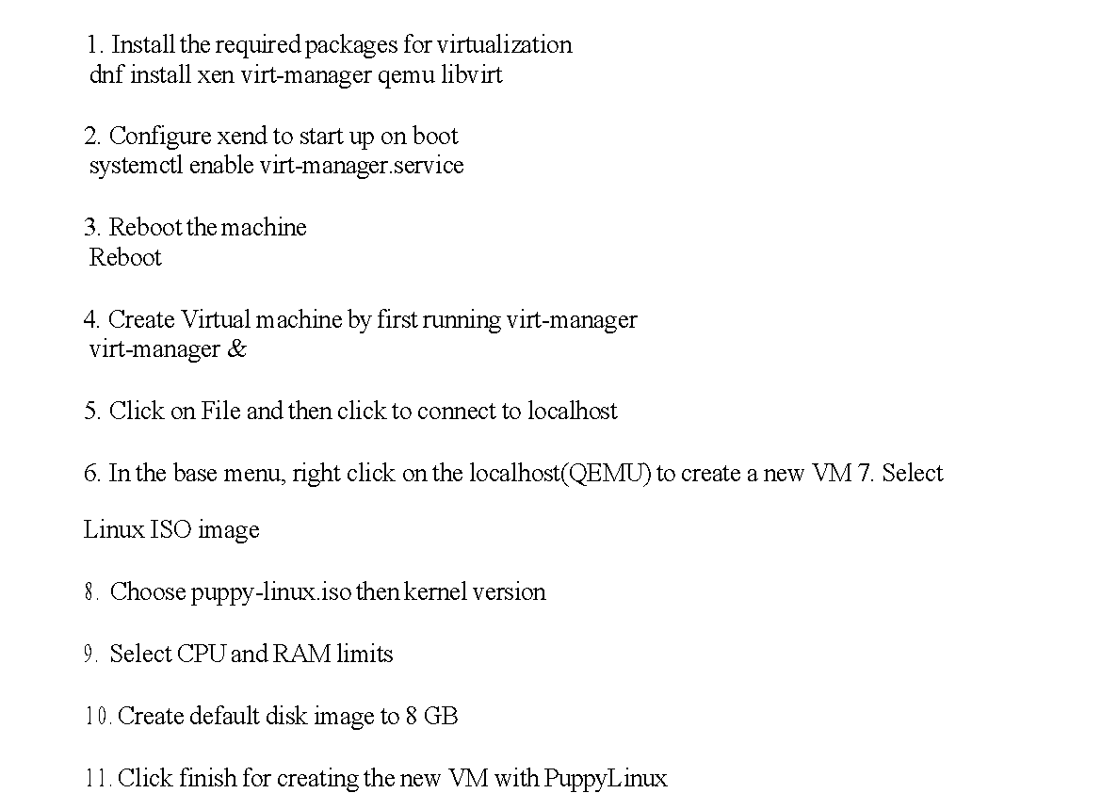

**OUTPUT:**

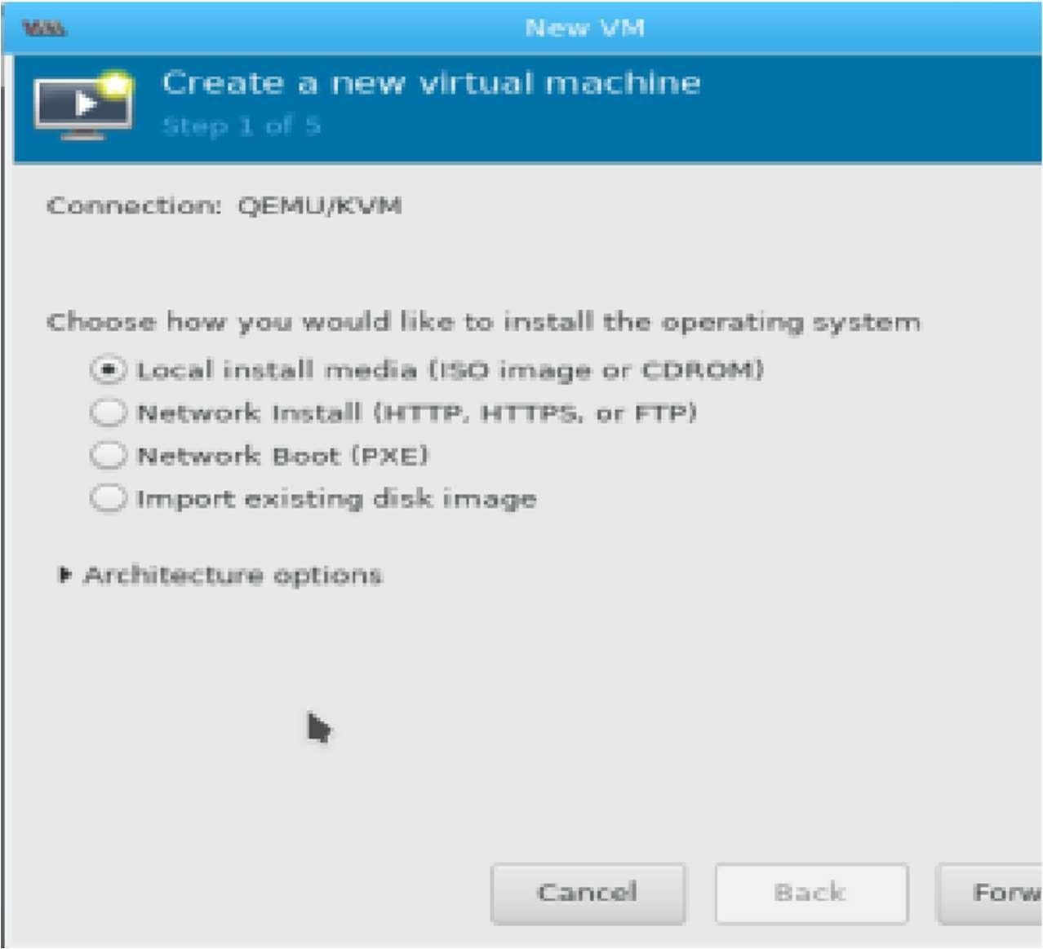

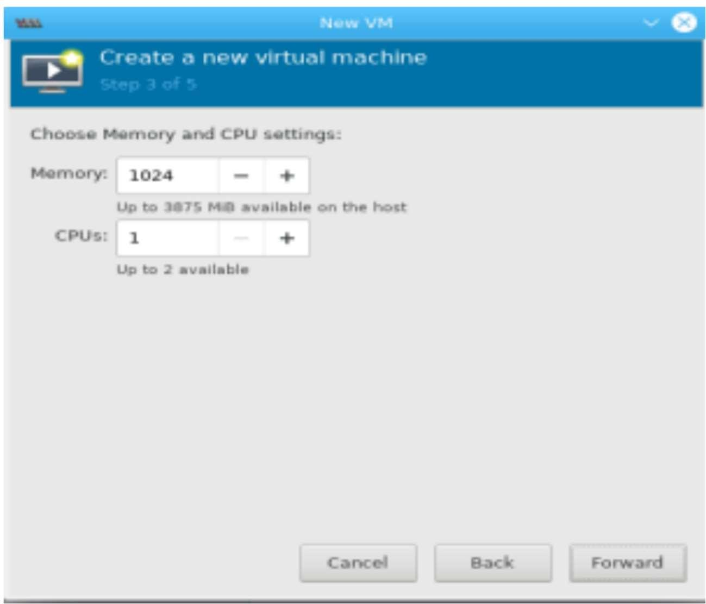

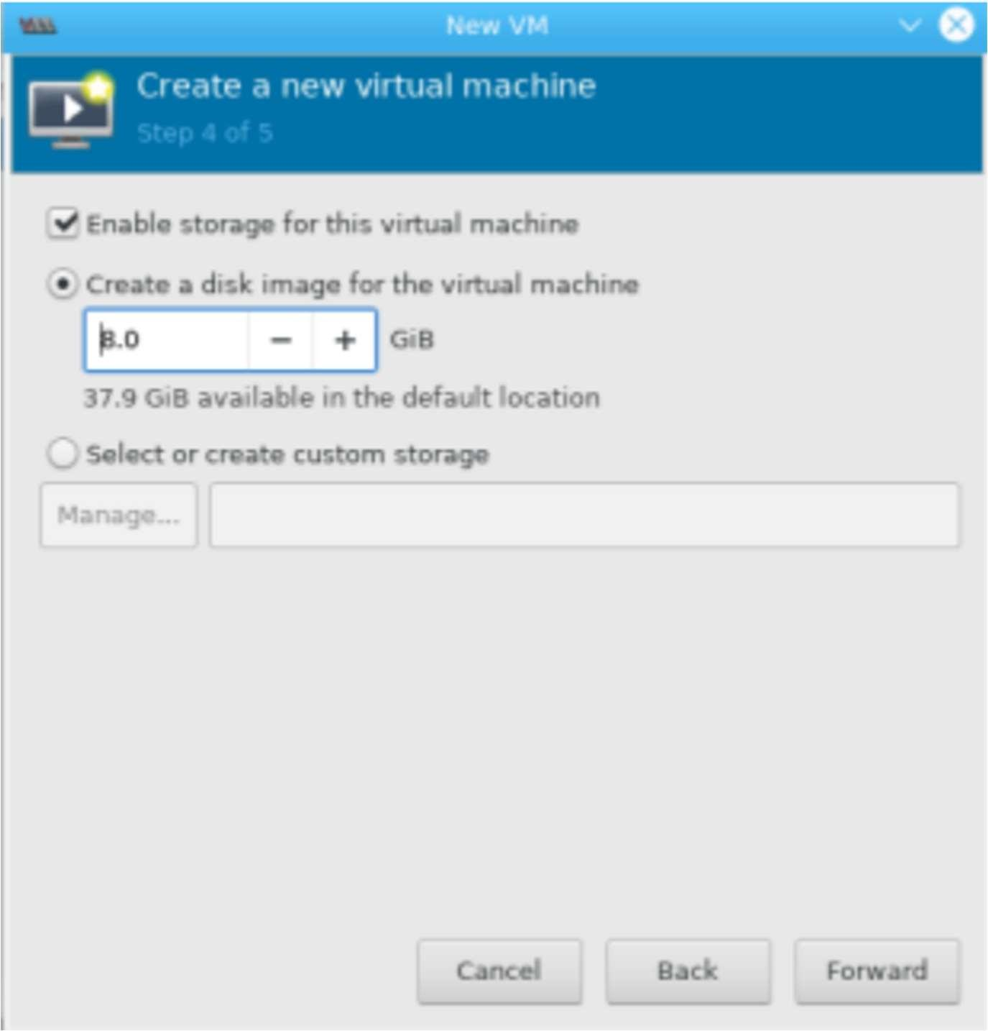

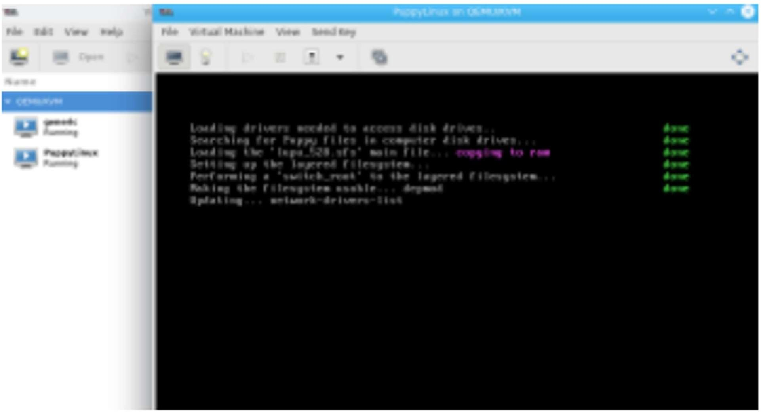

**RESULT:**

Installation and configuration of linux is completed successfully.